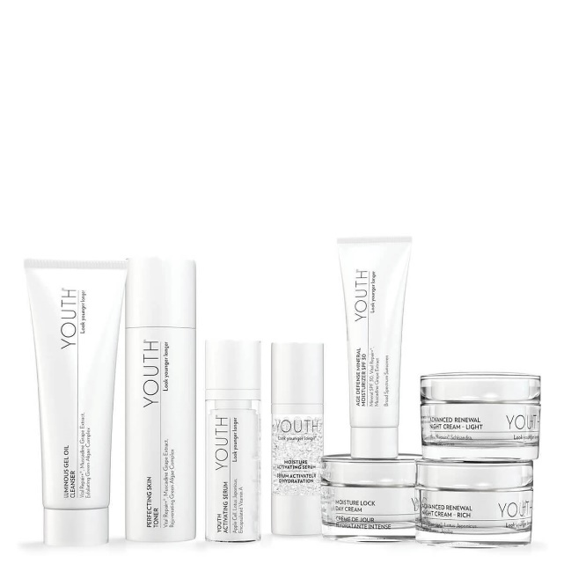
YOUTH® ORDER FORM
Advanced Anti-Aging Regimen #89453
$317.85 SRP $270.25 MP
Luminous Gel Oil Cleanser
Perfecting Skin Toner
Youth® Activating Serum
Age Defense Mineral Moisturizer SPF 30
Advanced Renewal Night Cream (Rich or Light)

Advanced Hydration Regimen #89504 $317.85 SRP $270.25 MP
Luminous Gel Oil Cleanser
Perfecting Skin Toner
Youth® Moisture Activating Serum
Moisture Lock Day Cream
Advanced Renewal Night Cream (Rich or Light)
Advanced Personalized Regimen #89504 $317.85 SRP $270.25 MP
Luminous Gel Oil Cleanser
Perfecting Skin Toner
Choose Youth® Activating or Moisture Activating Serum
Choose Age Defense Mineral Moisturizer SPF 30 or Moisture Lock Day Cream
Advanced Renewal Night Cream (Rich or Light)
Anti-Aging Regimen #89454 $216.05 SRP $183.70 MP
Luminous Gel Oil Cleanser
Perfecting Skin Toner
Age Defense Mineral Moisturizer SPF 30
Advanced Renewal Night Cream (Rich or Light)
Youth® Restoring Eye Treatment $63.65 SRP $54.10 MP
Youth® Radiance C&E $101.80 SRP $86.55 MP
Youth® Activating Beauty Balm Cream $44.50 SRP $37.80 MP
5-in-1 Beauty Balm evens, corrects, hydrates, nourishes, and protects with mineral, chemical-free SPF 30.
#32575 Light (works as a concealer) | #32577 Medium (gold undertones)
#32576 Light Medium (pink undertones) | #32578 Dark (great to blend/contour)
Youth® Lash Revitalizing Mascara $49.35 SRP $41.95 MP

I am interested in further information to become a Youth® Anti-Aging
Skin Care Consultant and earning upwards of $1000 a month.
(over)
Nutrition: The healthiest skin is built from the inside.
Vita Lea Iron #20288 120 tab  Vita Lea w/o Iron #20286  Vita Lea Gold (over 50) #20290 | $29.35 SRP $24.95 MP  $29.35 SRP $24.95 MP  $32.90 SRP $27.95 MP
Life Shake Energizing Shake 14 svg | $58.75 SRP $49.95 MP
Collagen-9 20 svg sticks  Collagen-9 40 svg canister | $38.75 SRP $32.95 $10 thru 2/21 $64.65 SRP $54.95 MP
Stress: When stress shows up on the face and stress lines appear.
B Complex #20186 | $27.55 SRP $23.40 MP
Stress Relief Complex #20656 | $35.00 SRP $29.75 MP

Name:
Cell Phone:
Email:
Birthday:
Shipping Address: Billing & Shipping addr same.
If no:

Credit Card: Exp date: CSV:

